HIGH ONGAR

PARISH COUNCIL

FINAL ACCOUNTS 2025/2026

Clerk
Bonnie Jones

Financial Summary 2025/2026
We started the year with £46,828.45 in the bank.
The precept set for 2025/2026 was £13,843
The total income (including precept) for 2025/2026 was £14,983.91. This was against a budgeted income of £13,843 – a difference of £1,140.91. The difference can be accounted for by way of bank interest of £897.66, £170 that was returned from Heelis & Lodge following a double payment and £50 returned payment from EALC following an overspend.
The total expenditure for 2025/2026 was £22,392.12 (this includes VAT of £1,781.44) versus a presumed budget expenditure of £14,433 – an overspend of £7,959.12. This overspend can be accounted for on the various budget headings as follows:
- £1,781 VAT payments
- £170 overspend on Audit. This was due to the payment being made twice in error. This was later rectified and returned.
- £120.28 overspend on Computer Maintenance and Software. This was due to an unforeseen increase in the website domain and hosting costs.
- An overspend on Subscriptions of £43.71. This was due to the 2025 and 2026 ICO subscriptions being paid in the same financial year.
- An overspend of £24.80 on Dog bins. This was due to a slight unforeseen price increase in May 2025. It increased each collection by 45p.
- A significant overspend of £3,634.50 on Streetlighting. This can be accounted for by way of repairs undertaken following the Structural testing of all the streetlights, unforeseen street light repairs to 3 different streetlights as well as repairs and change carried out following A&J Lightings Annual Streetlight maintenance.
- £3,966.82 overspend on additional items including £950 on various items for the VE Day celebration, £1700 grant given to High Ongar Village Hall for repairs to their shutters, £856.95 for 4 new defibrillator batteries and a spare set of pads, £206.33 on Employers NI and tax deductions which was not forecasted in the budget, £82.50 for EFDC Summer Play in the Park session and £172 on a new Paslow Common sign (defibrillator costs and High Ongar Village Hall Grant were taken from earmarked reserves but were not specifically budgeted for)

As neither the income nor expenditure was over £25,000, the Parish Council is able to declare itself exempt from the Limited Assurance Regime Audit.

The 2025/2026 bank reconciliation is as follows:
The net balances reconcile to the Cash Book (receipts and payments account) for the year, as follows:

CASH BOOK:  Opening Balance 1 April 2025  Add: Receipts in the year  Less: Payments in the year |  | £46,828.45  £14,983.91  (£22,392.12)
Closing balance per cash book as of 31 March 2026 |  | £39,420.24

Unity Trust 20520573 Current: £1,122.58
Unity Trust 20520586 Deposit: £38,297.66
TOTAL: £39,420.24

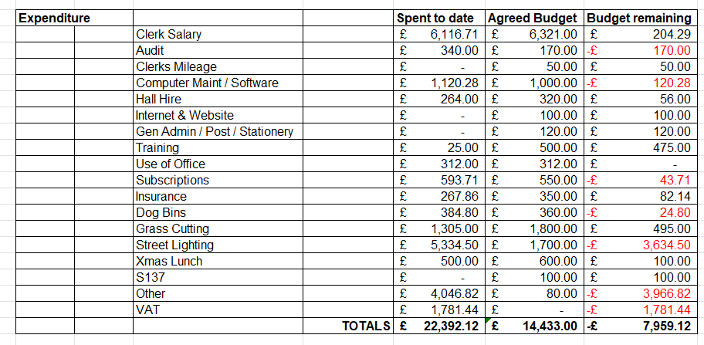

Reserves as of 31st March 2026

Specific Earmarked Funds
 |  | Spent | Remain
S/Lights | 6703.00 | 1910.80 | 4792.20
Defib | 9077.77 | 856.00 | 8221.77
Seating | 415.00 |  | 415.00
Elections | 1404.20 |  | 1404.20
Vandalism | 500.00 |  | 500.00
Open Spaces | 2000.00 |  | 2000.00
Speeding | 7373.00 |  | 7373.00
IT/Comp | 1500.00 |  | 1500.00
Events | 2000.00 |  | 2000.00
 |  | Total Earmarked | 28,206.17

General Reserves £11,214.07

